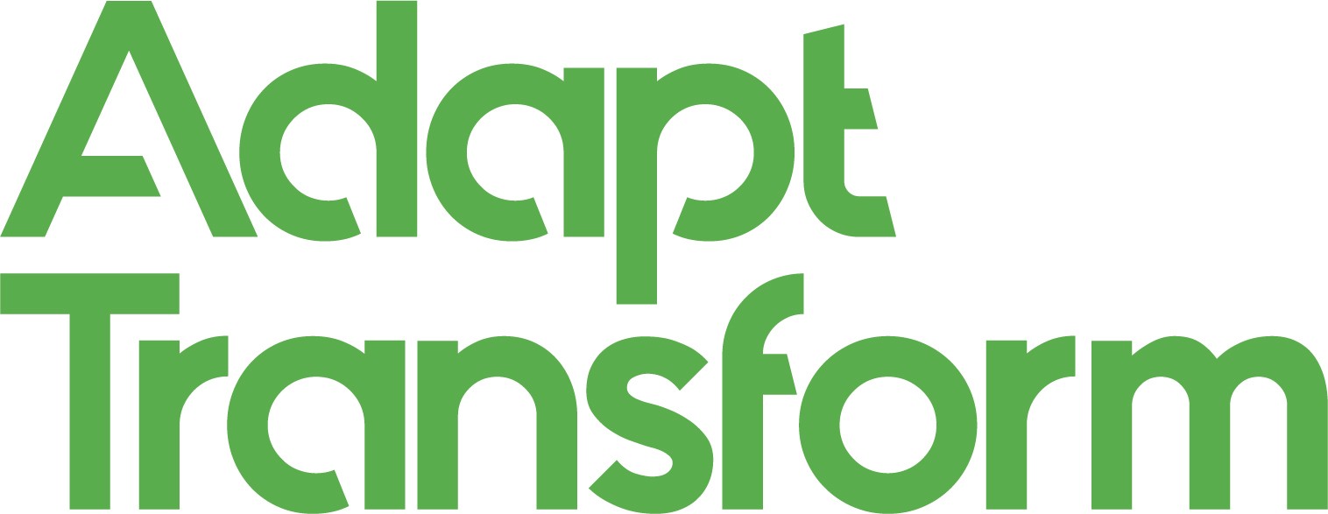

Application pack for Adapt Transform

Thank you for your interest in applying to take part in the Adapt Transform exhibition. You will find all the information you need in this pack to assist in your submission.
- Introduction
- The brief
- Key dates
- How to submit your work

Introduction

Modern Art Oxford and Oxford Brookes University invite people based in Oxfordshire to submit their creative responses to Adapt Transform, a new interdisciplinary exhibition exploring urban design and creativity.

Selected submissions will feature in a collaborative exhibition from 16 August - 25 September, installed as a conversation between two distinct exhibition sites: The Glass Tank Gallery at Oxford Brookes University and the ground floor space at Modern Art Oxford.

The exhibition will explore community experiences of urban design that impact the transformation of places over time, bringing a range of lived experiences together to discover how the planning and design of the cityscape impacts the way we live.
This is the third year of a research based collaborative project that is co-curated by members of the volunteer team at Modern Art Oxford.

Over half the world’s population live in cities, which is expected to grow to 68% by 2050. ‘By 2030, the world is projected to have 43 megacities with more than 10 million inhabitants’.

The rate of urbanisation has had a significant impact on the environment, and our health and happiness, with recent research showing rates of depression are among 40% higher in urban areas than in other populations.

The need for global leaders to address these shifts resulting from urbanisation are entwined with the choices we each make, and the experiences we have as communities.

Adapt Transform asks us to consider how our individual experiences in cities could inform design processes to shape our urban spaces. It invites communities to collaborate with new ideas and concepts that could transform existing structures using regenerative projects to ‘design out pollution’ and enhance a sense of community.

The brief

How can cities be designed with communities in mind, providing the social spaces we each need to connect?

And how can new concepts for architecture and design change the impact we have on the planet?

For this co-curated show, we are interested in receiving submissions inspired by any profession or personal experience, which resonate with the theme and reflect how we interact with architecture and design in our urban communities.

Adapt Transform will explore urban design and architecture through new and emerging concepts such as design for disassembly (DfD) and circular economies to encourage an understanding of architecture’s impact on communities.

Design for Disassembly is a design process where buildings can be deconstructed to their component material parts increasing the potential of re-use.
Circular Economies are driven by design, they eliminate waste, use and re-use materials and products for as long as possible, and support the natural world with regenerative methods that support natural resources.

We are particularly interested in exploring the ways in which design can support better use of materials, designing out waste and pollution, or telling a story that supports a thriving community with strong social networks. We encourage responses which consider how regeneration projects in urban spaces can create meaningful social connections and support other non-human species.

Submissions can take many different forms, such as drawings, proposals, models or prototypes. We welcome designs of buildings, social spaces, furniture and more that consider these principles of designing for city spaces. We are interested in concepts and designs that use materials in a responsible way; that can be re-used or adapted; or designed to be temporary but conducive to the environment.

What you need to know

Adapt Transform is an exhibition that will take place across two sites from 16 August – 25 September 2022.

The two exhibition sites are: The Glass Tank Gallery at Oxford Brookes University & the ground floor space at Modern Art Oxford.

The curatorial group will decide on the location of your work, and it is envisaged that the final selection will present a dialogue between both locations, relating to the project theme.

A total of 15 works will be selected for the final exhibition by our volunteer co-curators. Specialist production teams from Oxford Brookes University and Modern Art Oxford will be handling your work and supporting the curators throughout the install process.

If you are successful, we would require you to be available to meet the curatorial team on Monday 20 June between 3-5pm.

This will be an opportunity to meet other selected creatives for the show and confirm the next stages of the project.

We would ask that you consider yourself to be as much of a collaborative participation in this new and exciting project as our volunteers and audience.

Key Dates
- Installing from: 8 – 15 August
Preview: Friday 19 August, 6–9:30pm at Modern Art Oxford
- Exhibition: 16 August – 25 September 2022

How to submit your work

You do not have to pay anything to submit your work.
To submit, please send the following as one attachment to: Sara Lowes - Adapt Transform at creativelearning@modernartoxford.org.uk:

- Up to three images of the work or ideas you are submitting. These should be in jpeg format, each no larger than 0.5MB, and saved as your name and the name of the work.
- If you are submitting film or audio works, please send these as URL links only (such as via YouTube, Vimeo or SoundCloud).
- A short-written description of the work (including any links you would like to share) and its relationship to urban design and creativity. This should be no longer than 300 words. Include your name, the name of the work, the dimensions, requirements (if any) for display, materials, and date of production. This should be saved as a Word Document.
- Clear recommendations on handling the work.

The deadline for submissions is 5pm on Monday 30 May 2022.

If your work is selected, you will be contacted by Sara Lowes, Curator of Creative Learning on Friday 10 June.

Please note: we are asking for electronic submissions only at this stage – please do not send any original material.
- We regularly receive a high number of submissions for projects and exhibitions and therefore can only provide feedback on individual submissions that might be taken forward for the exhibition.
- Any work that does not follow the above submission requirements will not be considered for inclusion in the exhibition.
- If you require any support with your submission please contact creativelearning@modernartoxford.org.uk.

The final selection process will take place on Monday 6 June at Modern Art Oxford by our Modern Art Oxford Volunteers.

Successful submissions

If you are successful, we will make arrangements with you for the loan of your work from Monday 8 August to Friday 30 September.

Modern Art Oxford will assume all costs for packing and transportation of the loan to and from the exhibition site, unless agreed otherwise.

Please note: there is no fee for this loan, however an agreement to assure you (lenders warranties) of Modern Art Oxford’s (borrowers obligations) terms and conditions will be appropriately undertaken to secure all the necessary documentation for the purposes of this participatory project.

Oxford Brookes and Modern Art Oxford will share joint responsibility for the safe storage, installation and return of your work during this time.

Thank you for your interest in Adapt Transform. We look forward to
receiving your submission and welcome creative ideas from all ages, professions, and disciplines.

