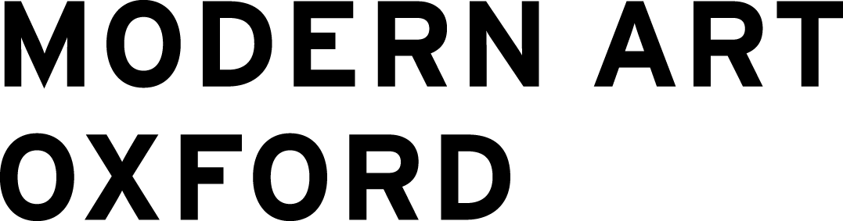
FAQs
Modern Art Oxford Creative Consultancy 2021/22

What is my role on the project as a Creative Consultant 2021/22?
Modern Art Oxford’s Creative Consultants will offer creative ideas, consultancy and feedback on a new public art project, playing a key role in the development of this new artwork which will launch in early 2022. Creative Consultants will be offered various opportunities to engage in skills development and professional development across the project, through exploring creative processes, learning about free, open access game making tools and having 1:1 professional development conversations with members of the Modern Art Oxford team.

Who can apply for this opportunity and do I need any existing skills?
Anyone aged 18-25 can take part. Since this is an online only opportunity, you do not need to be close to the gallery in Oxford to take part. You also do not need any skills or previous experience, but an interest in creativity is essential. Because this is a project that touches upon themes of decision making and testing different scenarios, we think the Creative Consultancy sessions will be particularly useful for individuals who may be interested in exploring fresh or different directions in their life, such as learning digital skills or looking to pursue creative education, training or career opportunities.
What are some of the experiences or skills I might get out of this project?
This project will include creative consultancy, and opportunities for skills and professional development.

Creative consultancy: You’ll work closely with the creative team across the development of Modern Art Oxford’s new digital participatory artwork and have the opportunity to learn how to plan, create and share your own piece of interactive storytelling. You’ll be asked about your opinions, thoughts and experiences of the digital participatory artwork while it's being developed, through a process called ‘playtesting’.

Skills development: You’ll learn about free, open source tools available for you to make games at home.

Professional development: This project also offers Creative Consultants a chance to gain some ongoing professional development, including a 1:1 careers chat with one of our team.
What will you do with my ideas or contribution? Will it go public?
This project is interested in inspiring young adults through the exchange of stories, ideas, games and other forms of creativity. There might be times where we share outputs from a Creative Consultancy session, perhaps a theme that was discussed or some anonymous quotes.

As part of the Creative Consultancy process, we’ll discuss ideas and relationships to the future, discussing what might happen, what we want to happen and how we feel about it? We’ll talk about what the future means to all of us. Ideas from these conversations will be used to inspire the final digital participatory artwork. This will happen as a process of dialogue or exchange. For example, you discuss your fears about the world getting warmer, then the final artwork includes a story about a strange summer storm.

You’ll be asked to ‘playtest’ short experiences. When you playtest, you’ll be experiencing something that is still in development, and you will be asked for your experience of it: was it fun? Easy to play? What did you respond to? What was meaningful? Your responses will be used to develop the digital participatory artwork. For example, if you found a screen hard to navigate, we’ll look at simplifying the process, if you wanted more choices, we might look at expanding options.

If we use your ideas, we will always ask permission well in advance. Any creative thoughts, words, images and other artworks resulting from these sessions will be treated as the individual’s own intellectual property, which they always reserve the right to keep private if they wish.

What is the online space like and will you record the sessions?
The Creative Consultancy sessions will take place in a secure Zoom meeting format. We'll invite everyone to turn on their cameras as we think this is a great way of making it feel more like we're in the same room, but you won’t have to turn on your camera if you’d prefer not to.

No sessions will be recorded, however we will take some notes. We’ll always be clear about when we are note-taking and when we are not. If you say something you don’t want to be noted down at any point, just let us know verbally or in the written chat. You can also get in touch after a session and ask something you said to be removed from any notes taken.

The session will be built around an ethos of respect and inclusivity, with a focus on respecting each other’s opinions, perspectives and creations. The online space is adaptable and will also be shaped by everyone involved in the project, and is open for you to change. We’ll check in regularly to make sure the space is working well for us all. If there is ever anything we can do to make you feel more safe, comfortable or welcome, do let us know throughout the process.

I can’t come to all the sessions, can I still join?
We would ask that you be available for all sessions, to ensure you get the most out of the experience. However, if there is one session you can’t attend we still recommend applying and simply letting us know.
I don’t have access to a device or the internet, can I still take part?
If accessing technology or WIFI will be a challenge for you, just let us know and we can help as best we can. Space, computers and refreshments will be available in the gallery in Oxford if anyone wants to join us there. The Zoom sessions are best experienced on a computer. However, there is absolutely no need for a computer if you'd prefer to join us via a tablet or a phone.
Can I chat to someone first before committing?
If you have any other questions about this opportunity, the quickest way to get in touch is to email media@modernartoxford.org.uk. You can also visit the gallery between 10am-5pm on Wednesdays and Fridays to speak to a member of the team in person - just ask anyone wearing a Modern Art Oxford badge to let Andree (Curator, Digital Content) know you have arrived and she will come and meet you. If you prefer talking on the phone, you can call +44 (0) 1865 722733 and ask for Andree.

