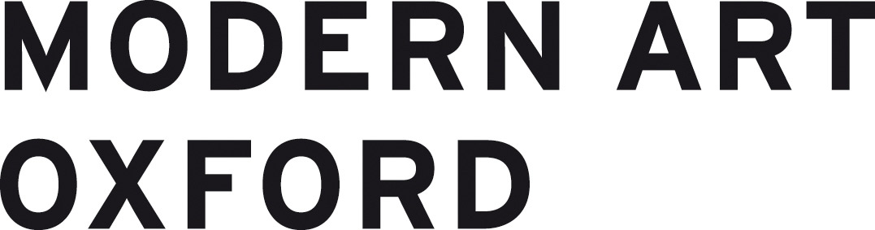

Equal Opportunities Monitoring Form 2021

We are committed to ensuring equality of opportunity in employment for all. We are committed to recruiting, retaining and developing a workforce that reflects the diverse communities that we are a part of. In order to do this, we need to monitor and analyse diversity information so that we can ensure our recruitment processes are fair, transparent, promote equality of opportunity and do not have an adverse impact on any particular group. You are not obliged to fill in this form but it would greatly assist us in monitoring the impact of our Equality, Diversity and Inclusion policy. The information on this form is confidential and will not form part of the shortlisting process. No information will be published or used in any way which allows individuals to be identified.

There is a "prefer not to say" option for each section if you would rather not answer a particular question.

1. How do you describe your gender identity?

Female (including trans women)
Male (including trans men)
Non-binary (e.g. Androgyne)
Prefer not to say

2. Is your gender identity different to the sex you were assumed to be at birth?

Yes
No
Prefer not to say

3. What is your age?

0-19
20-34
35-49
50-64
65+
Prefer not to say

4. Do you identify as a D/deaf or disabled person, or have a long-term health condition? Any information you provide here will be used for monitoring purposes only – if you require any reasonable adjustments to be made in the selection process then please contact recruitment@modernartoxford.org.uk

Yes
No
Prefer not to say

5. How do you describe your ethnic background?

Arab
Black African
Black Caribbean
Any other Black background
Indian
Pakistani
Bangladeshi
Chinese
Any Other Asian background
White British
White Irish
Gypsy or Irish Traveller
Any Other White background
White & Black Caribbean
White & Black African
White & Asian
Any other Mixed background
Any Other ethnic group
Prefer not to say

6. How do you describe your sexual orientation?

Bisexual
Gay man
Gay woman/Lesbian
Heterosexual/Straight
Queer
Prefer not to say

7. Where did you see this post advertised?

Thank you for completing this form!

